Name: _________________
Date: _________

The Tell-Tale Heart Vocabulary Words and Definitions (Monday 1/6/2020)

- Audacity: _____________________________________________________
- Agony: _______________________________________________________
- Dissimulation: _________________________________________________
- Foresight: _____________________________________________________
- Gesticulation: __________________________________________________
- Profound: _____________________________________________________
- Sagacity: _____________________________________________________
- Stealthily: _____________________________________________________
- Stifled: _______________________________________________________
- Vehemently: ___________________________________________________
- Vex: _________________________________________________________
- Wary: ________________________________________________________

Name: ______________________
Date: __________
The Tell-Tale Heart Vocabulary (Tuesday 1/7/2020)
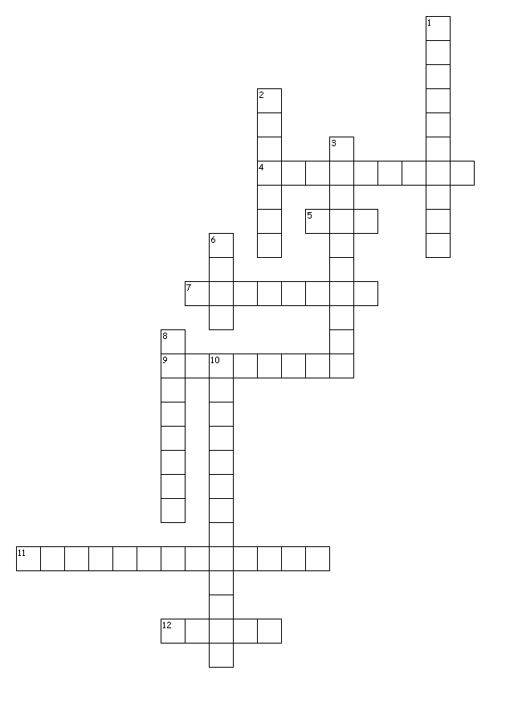
Across
4. the ability to predict what will happen or be needed in the future.
5. to confuse or annoy
7. deep; insightful
9. rude boldness; nerve
11. a gesture, especially a dramatic one, used instead of speaking or to emphasize one's words.
12. extreme physical or mental suffering
Down
1. in a secretive or sneaky manner
2. smothered; suppressed
3. marked by intense force or emotion
6. cautious
8. wisdom
10. a hiding of one's true feelings
Name: _________________
Date: _________

The Tell-Tale Heart Vocabulary Sentences (Wednesday 1/8/2020)

Choose six of the following terms and one of your individual vocabulary terms. Write an original sentence for each term of the selected terms.

Audacity Agony Dissimulation Foresight
Gesticulation Profound Sagacity Stealthily
Stifled Vehemently Vexed Wary
Ex: Term: Sentence____________________________________________
- ________________________________________________________________
- ________________________________________________________________
- ________________________________________________________________
- ________________________________________________________________
- ________________________________________________________________
- ________________________________________________________________
Individual Vocabulary Term—from the ones you added
- ________________________________________________________________

Name: _________________
Date: _________

The Tell-Tale Heart Vocabulary Memory Cues (Thursday 1/9/2020)
Compose a memory cue for the six REMANAINING terms from the vocabulary list and one of your individual vocabulary terms. REMEMBER these words should be DIFFERENT than the words you used for your sentences on the previous page.

Audacity Agony Dissimulation Foresight
Gesticulation Profound Sagacity Stealthily
Stifled Vehemently Vexed Wary
Ex: Term | Memory Cue

